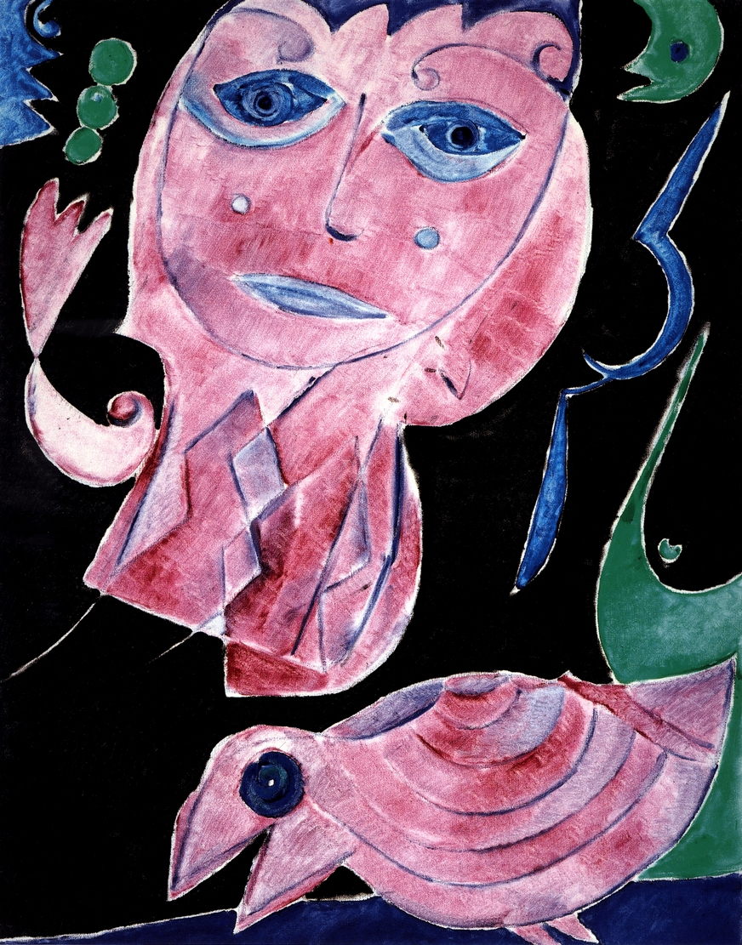DOCUMENT 1 Carl-Henning Pedersen, Pink Encounter (huile sur toile 1973), in Carl-Henning Pedersen, ed. GuyPieters ;

